Course Outline

Day 1

PMP Exam Prep Introduction
- What’s Project Management?
- Who’s PMI®?
- What’s the PMBOK®?
- What’s a PMP® and How to Become One?

Project Management Framework

– Introduction
- What’s a Project?
- Operations, Programs, Subprojects & Portfolios
- Why are Projects Authorized?
- Progressive Elaboration and the Triple Constraint
- How is the PMBOK® Organized?
- The Nine Knowledge Areas
- What Knowledge and Skills Does the Project Management Team Need?
- The Project Management Office

– Project Life Cycle & Organization
- Project Life Cycle
- Phases
- Project vs Product Life Cycles
- Stakeholders
- Organizational Influences on Projects

Project Management Processes
- Project Management Processes
- Project Management Process Groups
- Project Success Factors
- Initiating Processes
- Planning Processes
- Executing Processing
- Monitoring & Controlling Processes
- Closing Processes

Day 2

Project Integration Management
- Day 1 Quiz
- Major Project Documents
- Develop Project Charter
- Develop Preliminary Project Scope Statement
- Develop Project Management Plan
- Direct & Manage Project Execution
- Monitor & Control Project Work
- Integrated Change Control
- Close Project

Project Scope Management
- Scope Planning
- Scope Definition
- Create WBS
- Scope Verification
- Scope Control

Day 3

Project Time Management
- Activity Definition
- Activity Sequencing
- Activity Resource Estimating
- Activity Duration Estimating
- Schedule Development
- Schedule Control

Project Cost Management
- Cost Estimating
- Cost Budgeting
- Cost Control

Project Communications Management
- Communications Planning
- Information Distribution
- Performance Reporting
- Manage Stakeholders

Day 4

Project Quality Management
- Quality Planning
- Perform Quality Assurance
- Perform Quality Control

Project Risk Management
- Risk Management Planning
- Risk Identification
- Qualitative Risk Analysis
- Quantitative Risk Analysis
- Risk Response Planning
- Risk Monitoring and Control

Project Human Resource Management
- Human Resource Planning
- Acquire Project Team
- Develop Project Team
- Manage Project Team

Day 5

Project Procurement Management
- Plan Purchase and Acquisitions
- Plan Contracting
- Request Seller Responses
- Select Sellers
- Contract Administration
- Contract Closure

Professional & Social Responsibility
- PMI PMP Code of Professional Conduct
- Sample Responsibility Questions

PMP® Exam Prep
- Interactive Group Puzzles
- Review of PMP® Certification Process
- Exam Strategies, Review and Q & A

Course Materials Provided

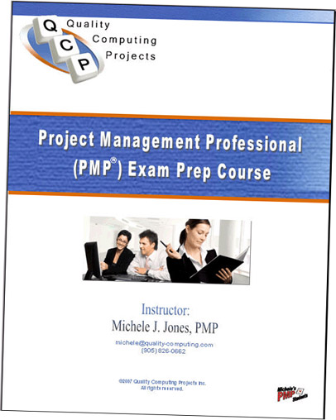
Course Notes
- Approximately 180 pages of course notes that are a great study resource
- Binder with section tabs

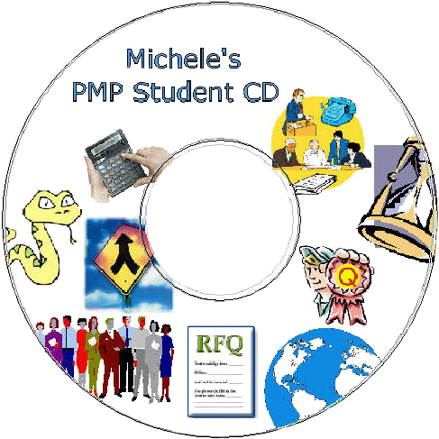
Michele’s Student CD
- Puzzles, worksheets, sample exam questions, reference material, study WBS, PM quotes, links to online sample exam questions & PM info
- All the stuff that Michele’s students asked for during class have been conveniently packaged on this helpful study CD

Project Management Institute’s A Guide to the Project Management Body of Knowledge Third Edition (PMBOK® Guide)
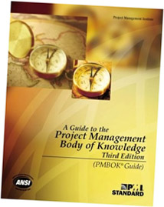
- Considered one of the most essential tools for any Project Management Practitioner’s library and the de facto and ANSI global standard for the industry
- 388-page paperback, English, January 2004
- Essential reading for PMI’s PMP exam
- 4th on BusinessWeek magazine’s list of best-selling paperback business books in October 2006
- Over 2 million copies in circulation worldwide
- $37 CAN Value

Rita Mulcahy, PMP’s PMP Exam Prep – Accelerated Learning to Pass PMI’s PMP Exam On Your FIRST Try!
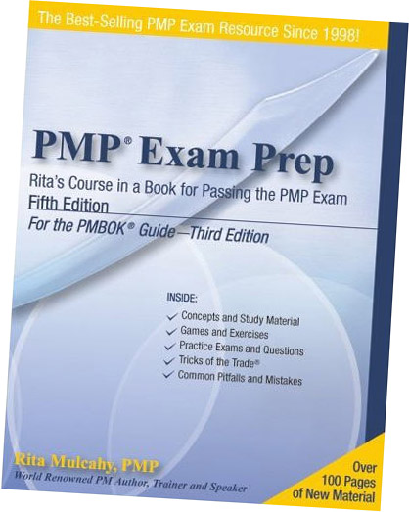
- Best-Selling PMP Exam Resource Since 1998 and one of the best in the world
- Includes 25 sample exam questions on CD
- 445-page paperback, English, September 2005
- Rita is an internationally recognized expert on project management Tricks of the Trade
- This is one of our student’s favorite study workbooks
- $80 CAN Value
- 2 equivalent books can be substituted by Andy Crowe or Joseph Phillips

Project Management Institute’s Q&As for the PMBOK® Guide Third Edition
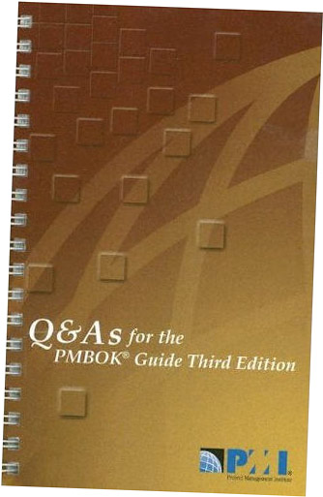
- 200 multiple choice questions & answers is a companion to the PMBOK Guide for PMP exam prep
- Covers the key themes and concepts of the project management framework and the nine project management knowledge areas
- 200-page spiral paperback, 2005
- $25 CAN Value

Instructor

Michele J. Jones, PMP
- Independent Computer/Business Consultant and Project Management Professional & Consultant
- Has taught this exact course for over 2 1/2 years

This course fulfills Project Management Institute’s 35-hour education requirement to apply for their PMP exam.

Check PMI’s website for the experience requirement at www.pmi.org/info/PDC_PMPHandbook.pdf (4500 hours with University or 7500 hours with High School leading and directing project tasks).

